Calculus 1 Lecture 3.3: The First Derivative Test for Increasing and Decreasing

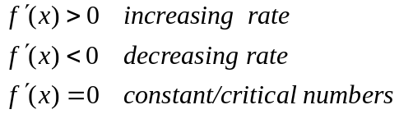

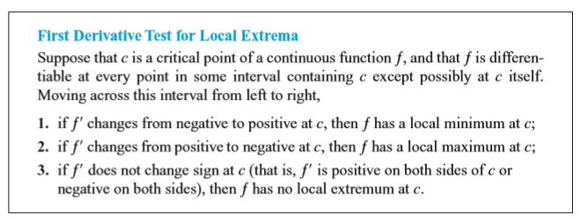

How to find relative extrema.
First derivative test.
1 Take the first derivative
2 Set first derivative to zero and find critical numbers.
- Graph critical numbers on a number line plus any undefined numbers (asymptote)
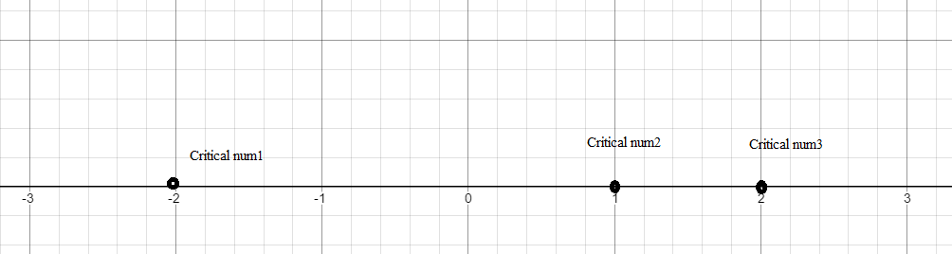
- Find the sign of each interval by plugging into the  formula using points from each interval.(this gives increasing or decreasing character of graph)

Example
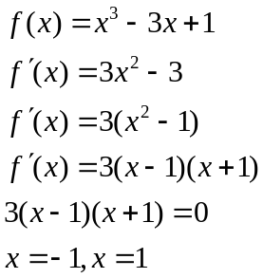

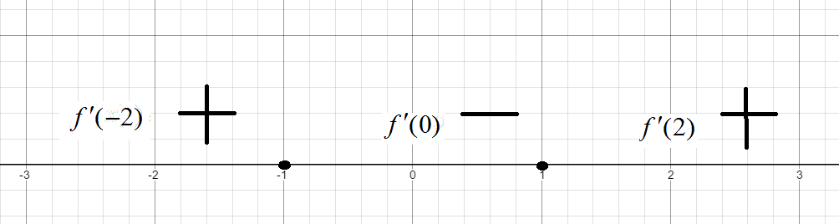

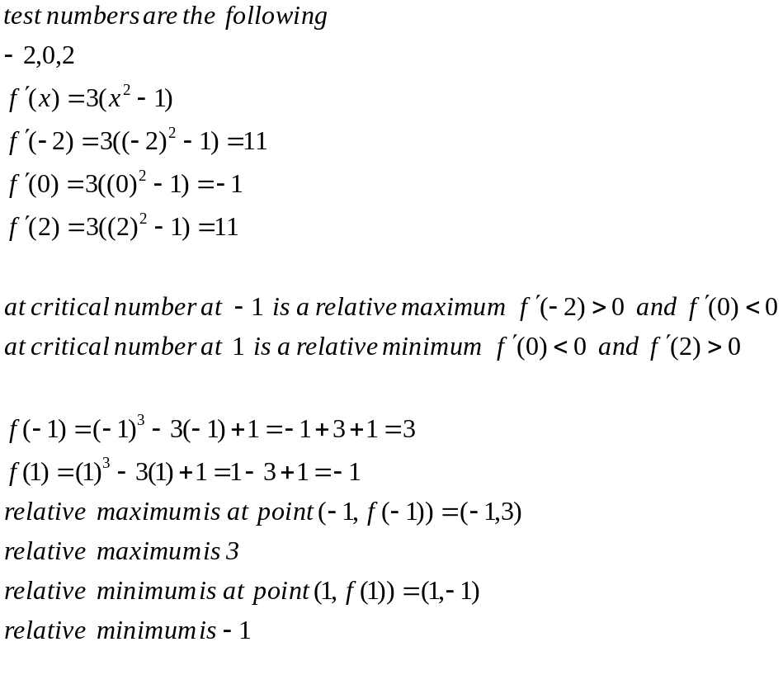

Changing signs means between intervals means a relative maximum or relative minimum exists
+- means relative maximum
-+ means relative minimum

Example
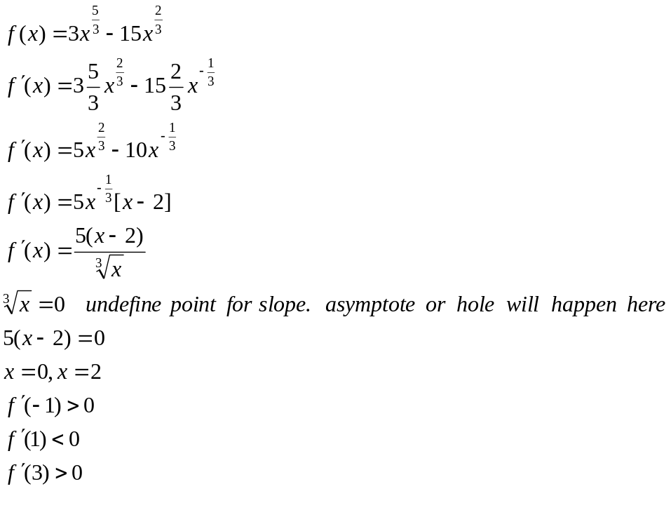
Note when the denominator can equal zero it must be considered a critical number.
